**UID Exam 1**

* HCI and Interaction Design



* **Ben Schneiderman** – founder of the University of Maryland Human-Computer Interaction Lab
  + Created the Eight Golden Rules of Design:
    - Strive for Consistency – consistent sequences should happen in similar situations
    - Enable Frequent Users to Use Shortcuts – reduce the number of interactions to increase the pace of interaction
    - Offer Informative Feedback – for every operator action, there should be some system feedback
    - Design Dialogue to Yield Closure
    - Offer Simple Error Handling **–** design the system so the user cannot make a serious error
    - Permit Easy Reversal of Actions
    - Support Internal Locus of Control
    - Reduce Short Term Memory Load
* **User Experience** – how a product behaves and is used by people in the real world
* **Process of Interaction Design** 
  + Establishing requirements
  + Developing activities
  + Prototyping
  + Evaluating
* **Usability Goals** -
  + Effective/Efficient/Safe to use
  + Easy to learn and remember to use
* **Conceptual Model** – developers view of the system
* **Mental Model** – users view of the system
* **Interface Metaphors** – conceptualizing what we are doing (ex. Surfing the web instead of literally surfing the web)
  + Interface designed to be similar to a physical entity but also has own properties
* **Interaction Types** – What the user is doing when interacting with a system
  + Instructing– Where users instruct a system and tell it what to do (ex. tell the time, print a file, save a file, etc.)
  + Conversing – Underlying model of having a conversation with another human (ex. Alexa or Siri)
  + Manipulating – Involves dragging, selecting, opening, closing, and zooming actions on virtual objects
    - Direct Manipulation– Physical actions and button pressing instead of issuing commands with complex syntax
  + Exploring – Involves users moving through virtual or physical environments (ex. VR)
* Empathy Map:

**[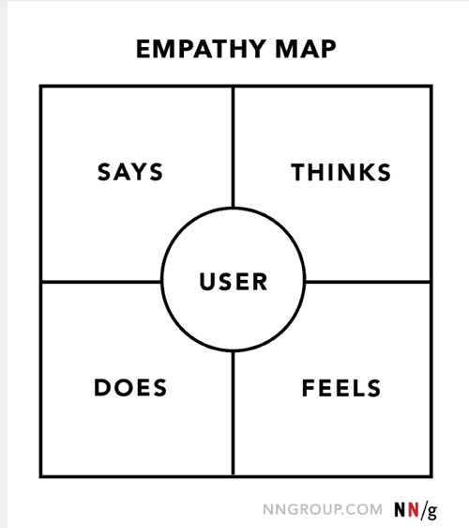](https://www.nngroup.com/articles/empathy-mapping/)**

* **Donald Norman** – Cognitive Process
  + Experimental Cognition – Perceive, act, and react to events around us effectively and effortlessly (ex. Driving a car, reading a book, having a conversation, etc.)
  + Reflective Cognition – Thinking, comparing, and decision making (ex. Design, learning, writing a book)
* **Memory** –
  + Sensory– buffers for stimuli received through senses (ex. “Sparkler” trails)
  + Short Term– Scratch pad for temporary recall (ex. You can remember 7 + or – 2 things – George Miller)
  + Long Term **–** Repository for all our knowledge
* **The Gulf of Execution** – Designers should think of how to bridge these gulfs to reduce cognitive efforts to perform a task
  + Distance from the user to the physical system
* **Gulf of Evacuation** **–** Distance from the physical system to the user
* **Distributed Cognition** – distribute the thinking process between a group of people (ex. Brainstorming as a team)
* **Computational Offloading** – When a tool is used in conjunction with an external representation to carry out a computation. (ex. Pen and paper, using a calculator to solve a problem vs solving it in your head)